Chat Application

1. Load Previous chat

For loading previous chat we have to call API along with channel_id for that while open buyer-sender conversation.

URL: http://<SERVER_IP>:<SERVER_PORT>/chat/loadPreviousChat

After calling above API you’ll get json response in below format:

{

‘buyer_id’: <buyer_id>,

‘seller_id’: <seller_id>,

‘nft_id’: <nft_id>,

‘message’: [] //list of message along with time

}

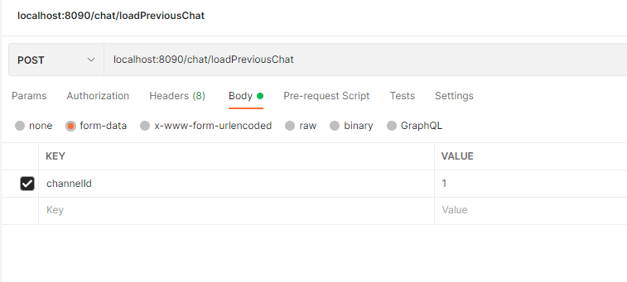Like..

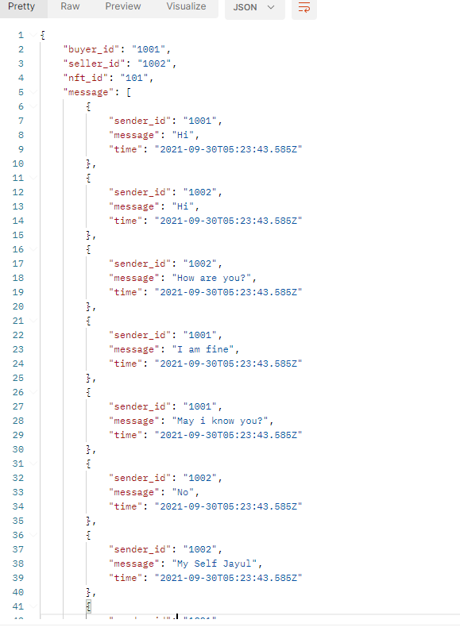

1. Add new Channel.

As we discuss on the call while buyer send chat request to seller for communication purpose. So while seller accepts the chat request so that time we have to call one API to create a channel for them.

URL: http://<SERVER_IP>:<SERVER_PORT>/chat/loadPreviousChat

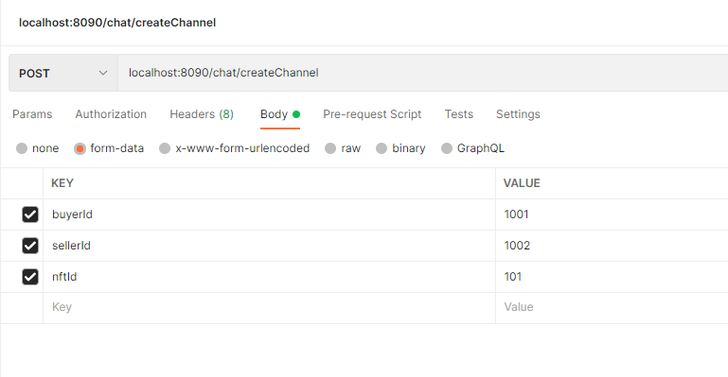

1. Load User list

While open chat application we have load list of user.

URL: http://<SERVER_IP>:<SERVER_PORT>/chat/getUserList

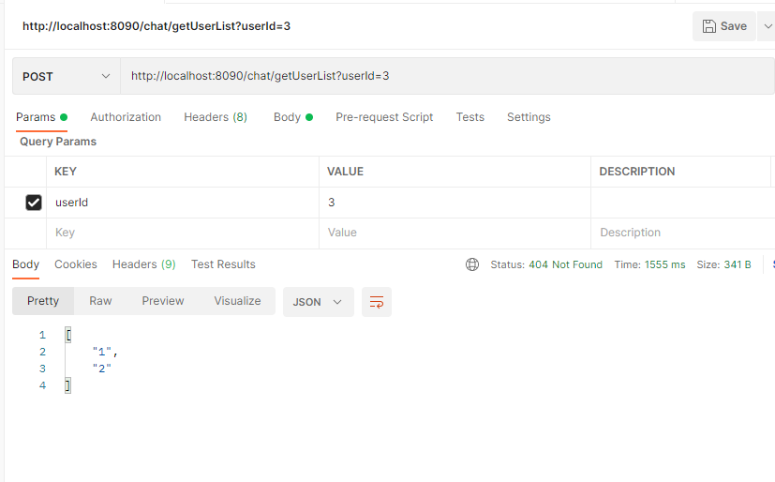

1. Top of Form
2. Bottom of Form